Coursework Report Template for Module INM433 “Visual Analytics”

Zacharias Detorakis

**Abstract**—Put here a brief summary of your work: analysis task, data, approach, main findings. Length: up to 200 words.

# Problem Statement

The objective of the analysis presented in this paper is to study the crime rates in London (i.e. by ward and by borough) overtime and try to see if there is any correlation with other characteristics of census data within the same geographical areas. Therefore, the key questions are:

* Is there a pattern in the increase/decrease of the crime rate overtime?
* Do these patterns, if they exist, have a spatial collocation (i.e. neighbouring boroughs following the same patterns of increase or decrease)
* Are crime rates correlated with other indices of the studied areas (i.e. demographics)?

The study spans a period of 9 years (2010-2018). In April 2010 there was a change in the ward code boundaries therefore the data available before 2010 are not considered to avoid skewing the results. The key socio-economic characteristics used for the analysis against the crime rates are:

* Gender: i.e. the makeup of the areas in terms of male, female population
* Employment: i.e. the employment status of the residents in those areas also broken down by gender and type of employment

The data collected for the indices that will be accessed for their impact in the crime rate are at borough rather than ward level so human reasoning supported by visual representation will be required to see if it is meaningful to group wards by borough for the purposes of this analysis.

# State of the Art

First paragraph...

Following paragraphs...

*<500 words*

# Properties of the Data

*<500 words, <=2 images*

The studied area in this research is Greater London which is a ceremonial county of England that makes up the majority of the London region. Greater London is divided into 32 local authority districts henceforth mentioned as *boroughs* each of which comprises multiple smaller subdivision henceforth mentioned as *wards*.

The data that is used in this analysis have been collected for the Greater London region over the course of the 9 years (2010-2018) and comprise the following datasets

Crime Data: Crime data was sourced from the metropolitan police and have been geographically aggregated at ward level (606) and subsequently at borough level (32). The timeseries have also been aggregated into monthly figures 105 instead of (12x9 = 108) months given that the oldest datapoints available are from April-10 instead of Jan-10. The crime records for each ward/month are broken down further by a major and minor classification of the crime as defined by the Home Office. There are 9 major crime classifications (Burglary, Criminal Damage, Drugs, Fraud or Forgery, Other Notifiable Offences, Robbery, Sexual Offences, Theft and Handling, Violence Against The Person) and 32 minor categories. Although data is not available at a lower grain (i.e. individual records per crime with locale and datetime information) the aggregation is still at a level that is useful for the analysis

Census Data:

Crime Data

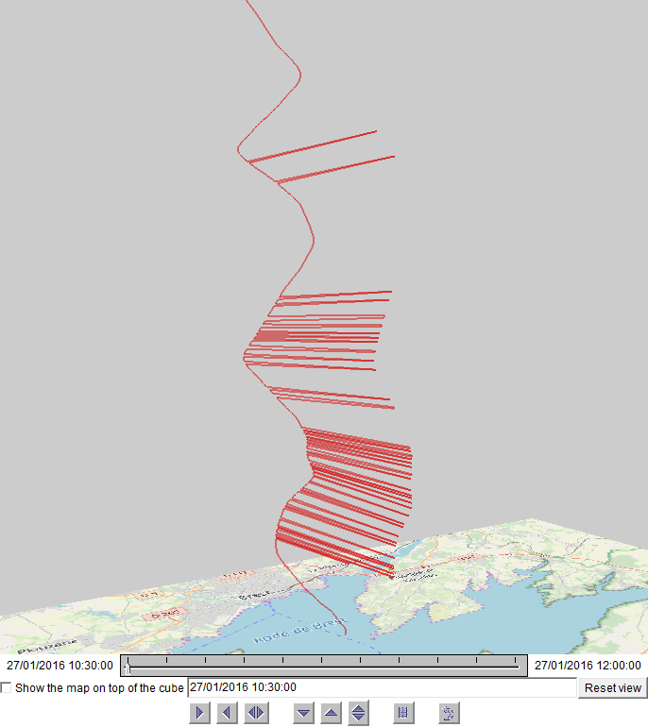

Fig. 2. An example of including a screenshot in the document.

## Results

First paragraph...

Following paragraphs...

*<200 words, <=2 images*

# Critical reflection

First paragraph...

Following paragraphs...

*<500 words*

Table of word counts

|  |  |
| --- | --- |
| Problem statement | 220/250 |
| State of the art | 500 |
| Properties of the data | 500 |
| Analysis: Approach | 500 |
| Analysis: Process | 1500 |
| Analysis: Results | 200 |
| Critical reflection | 500 |

References

The list below provides examples of formatting references.

1. M.Ankerst, M.Breunig, H.-P.Kriegel, J.Sander. OPTICS: Ordering points to identify the clustering structure. In: *ACM SIGMOD* 1999, pp. 49–60.
2. M. Bögl, W. Aigner, P. Filzmoser, T. Lammarsch, S. Miksch, and A. Rind. Visual Analytics for Model Selection in Time Series Analysis, *IEEE Trans. Visualization and Computer Graphics*, 19(12): 2237-2246, 2013.
3. T.F. Cox, M.A.A. Cox. *Multidimensional Scaling*. Chapman and Hall, 2001.
4. S. van den Elzen and J.J. van Wijk. BaobabView: Interactive construction and analysis of decision trees, *Proc. IEEE Conf. Visual Analytics Science and Technology (VAST’11)*, pp. 151-160, 2011.
5. M.Harrower, C.A.Brewer: Colorbrewer.org: An online tool for selecting color schemes for maps. *The Cartographic Journal* 40(1): 27–37, 2003.
6. T. Mühlbacher and H. Piringer. A Partition-Based Framework for Building and Validating Regression Models, *IEEE Trans. Visualization and Computer Graphics*, 19(12): 1962-1971, 2013.
7. D. Phan, L. Xiao, R. Yeh, P. Hanrahan, T. Winograd. Flow map layout. In *Proceedings of the IEEE Symposium on Information Visualization (InfoVis 2005)*, pp.219-224, Oct. 2005.
8. J.W. Sammon. A nonlinear mapping for data structure analysis. IEEE Transactions on Computers, 18(5): 401–409, May 1969.
9. J. Sewall, D. Wilkie, and M.C. Lin. Interactive Hybrid Simulation of Large-Scale Traffic, *ACM Transactions on Graphics*, 30(6), Article 135.
10. N. Willems, H. van de Wetering, J.J. van Wijk. Visualization of vessel movements. *Computer Graphics Forum*, 28(3): 959-966, Jun. 2009.